2021 Bond Program – 7,600,000 of $26.5 Million (Phase 1)
Project Name | Animal Control Facility  Budget: $3,700,000
Project Status | September 2025 Construction: 20%
Project Update | September 2025 - The wall framing and most of the flat roof have been installed. The windstorm inspector has conducted a site visit and is reviewing the design and materials used to ensure the structure is built correctly prior to placing the heavy roof over the kennel area. The remainder of the walls and roof will be installed and closed in as soon as he confirms the structure is built to specifications.

Any Additional Information for Public

Photos:
Animal Control Facility_September_1

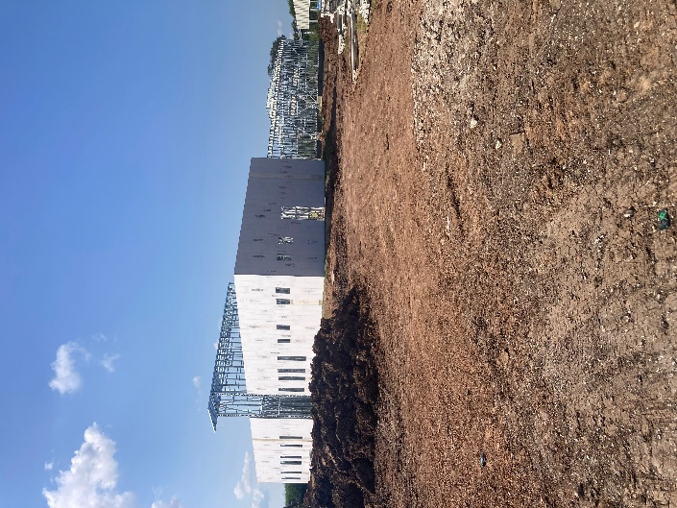

2021 Bond Program – 7,600,000 of $26.5 Million (Phase 1)
Project Name | Pin Oak, North Shady Oaks, Forest Oaks Ln Rehabilitation  Budget: $2,600,000
Project Status | September 2025 Construction: 99%
Project Update | September 2025 - The Contractor has substantially completed the project. They are replacing cracked concrete and installing asphalt where it was removed. Staff will be doing a final walkthrough of the project to find any minor issues and have them corrected prior to accepting the assets.

Any Additional Information for Public

Photos:
Pin Oak, North Shady Oaks, Forest Oaks Ln Rehabilitation_September_1

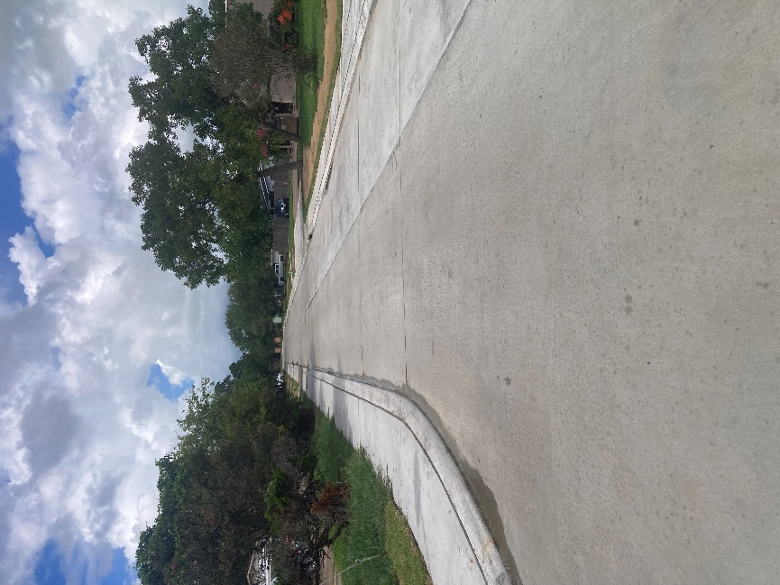

Pin Oak, North Shady Oaks, Forest Oaks Ln Rehabilitation_September_2

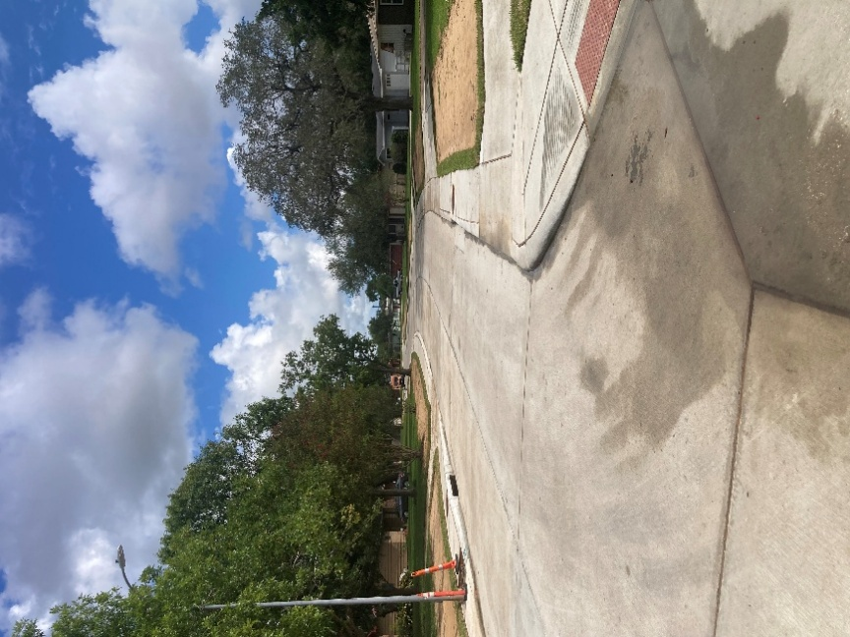

2021 Bond Program – 16,500,000 of $26.5 Million (Phase 2)
Project Name | Moss, Chestnut, Wisteria, Palm Ln Rehabilitation  Budget: $12,100,000
Project Status | September 2025 Construction: 0%
Project Update | September 2025 - The contractor has moved equipment to a temporary laydown yard on Chestnut Street. A Preconstruction Town Meeting has been scheduled for Thursday, October 9, 2025 for the residents in the neighborhood. The contractor is expected to start work on utilities and drainage after the meeting. Pavement work will follow the utilities and drainage replacement work. Press Releases will give more information about the work areas and traffic flow changes when work phases change.
Any Additional Information for Public | Preconstruction Town Meeting at the Lake Jackson Doris Williams Civic Center on Thursday, October 9, 2025 at 6:30 pm in the Plaza Rooms 1 and 2.

2021 Bond Program – 16,500,000 of $26.5 Million (Phase 2)
Project Name | Willenberg St., Balsam St., Sleepy Hollow Subdivision Street Rehabilitation  Budget: $2,900,000
Project Status | September 2025 Design: 100%  September 2025 Construction: 0%
Project Update | September 2025  Tentative Schedule  October 5: First Public Advertisement per State Law  October 12: Second Public Advertisement per State Law  October 22: Mandatory Pre-Bid Meeting with Contractors  October 31: Last Day for Contractor Questions  November 5: Bid Opening/Evaluation; Contractor Vetting  December 1: City Council Contractor Award Recommendation  December 2 – 31: Contract Documents, Preconstruction Meeting, Etc.  January 8, 2026 Preconstruction Town Meeting - Tentative  Mid to late January at the earliest: Mobilize Construction
Any Additional Information for Public | - Bond Sale awarded to Robert W. Baird & Co. Incorporated on November 20, 2023  - Bond Funds received December 18, 2023  - Engineering Contracts with Parra & CO., LLC were signed on March 28, 2024 and November 21, 2024

2021 Bond Program – 16,500,000 of $26.5 Million (Phase 2)
Project Name | Street Panel Replacement Phase 2  Budget: $1,500,000
Project Status | September 2025 Construction: 20%
Project Update | September 2025 - The contractor has continued working the inside lane of N. Yaupon Street. They have mobilized another crew to begin work on This Way westbound between Lake Road and Plum Circle.

Any Additional Information for Public

2025 Bond Program – $20,400,000 Million
Project Name | Police Department Expansion  Estimated Budget: $5,400,000 – ($3 Million was approved by voters in 2025 and $2.4 Million was approved by voters in 2021)
Project Status | September 2025 Design: 0%
Project Update | September 2025 - City staff is interviewing the two selected firms, iAD and PGAL, on October 8, 2025. Both firms were provided with the latest needs assessment for the project and asked to provide feedback at the interview.

Any Additional Information for Public

2025 Bond Program – $20,400,000 Million
Project Name | Fire Department – Station 1  Estimated Budget: $3,000,000
Project Status | September 2025 Design: 0%
Project Update | September 2025 - The City met with iAD to review the scope of the project; iAD submitted a proposal for the architectural and engineering services, and we plan to present the proposal to City Council for approval at the October 20, 2025 meeting.

Any Additional Information for Public

2025 Bond Program – $20,400,000 Million
Project Name | Street Panel Replacements  Estimated Budget: $8,100,000
Project Status | September 2025 Design: 0%  September 2025 Construction: 0%
Project Update | September 2025 - The surveying scope was delineated and will be presented to City Council on October 6, 2025 for approval to authorize the City Manager to execute a contract to perform the work.  Once approved, the field surveying will be begin so the worst street panels can be identified for replacement and the Engineers can begin to prepare their design engineering scopes.

Any Additional Information for Public

2025 Bond Program – $20,400,000 Million
Project Name | Drainage  Budget: $4,000,000
Project Status | September 2025 Design: 0%
Project Update | September 2025 – No current projects at this time.

Any Additional Information for Public

