2021 Bond Program – 7,600,000 of $26.5 Million (Phase 1)
Project Name | Animal Services Facility  Budget: $3,700,000
Project Status | July 2025 Construction: 10%
Project Update | July 2025 - The concrete building slab was poured July 23, 2025. The contractor is now waiting for the wall panel manufacturer to come supervise his workers to install them properly. Meanwhile some of the other site concrete is being formed and placed.

Any Additional Information for Public

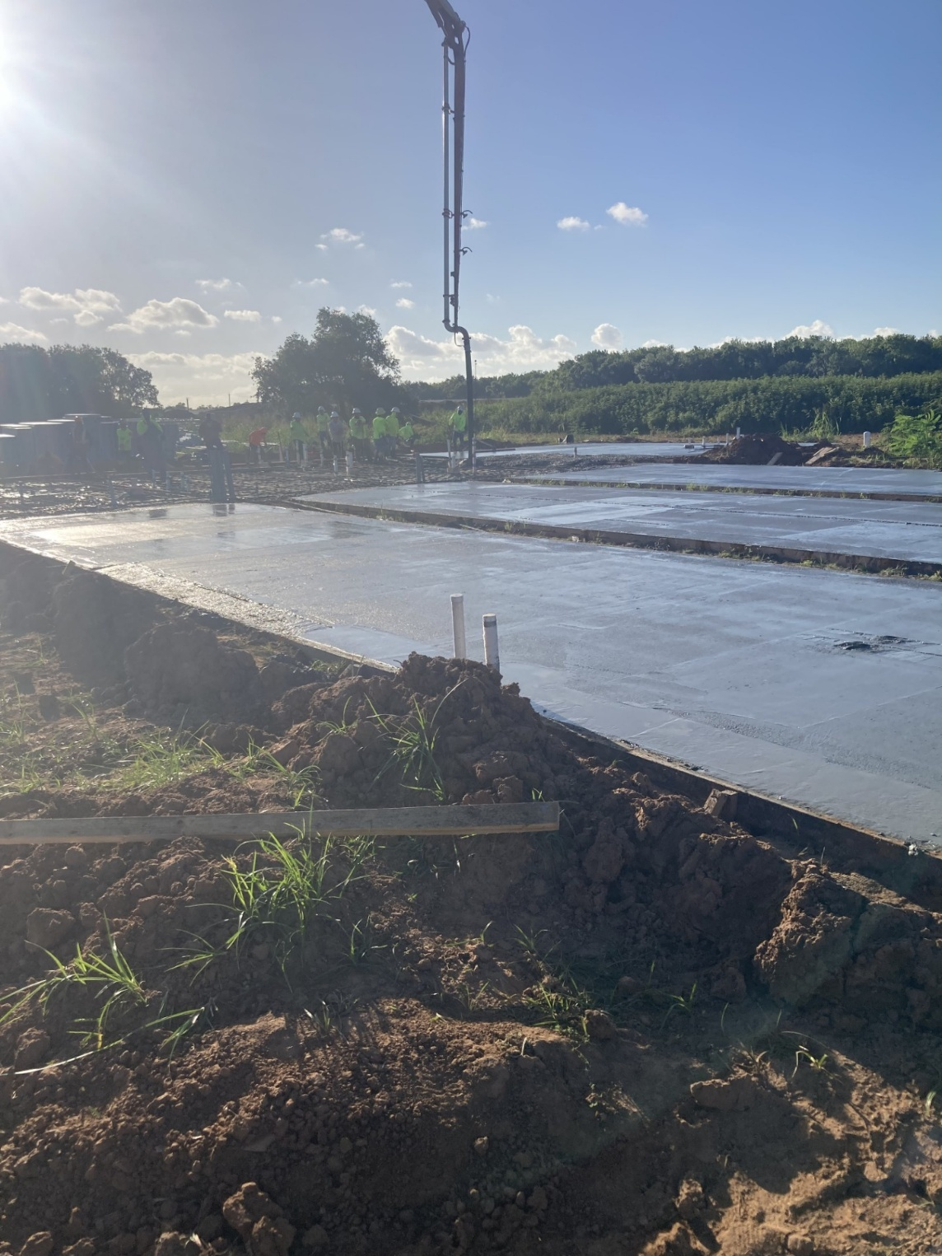

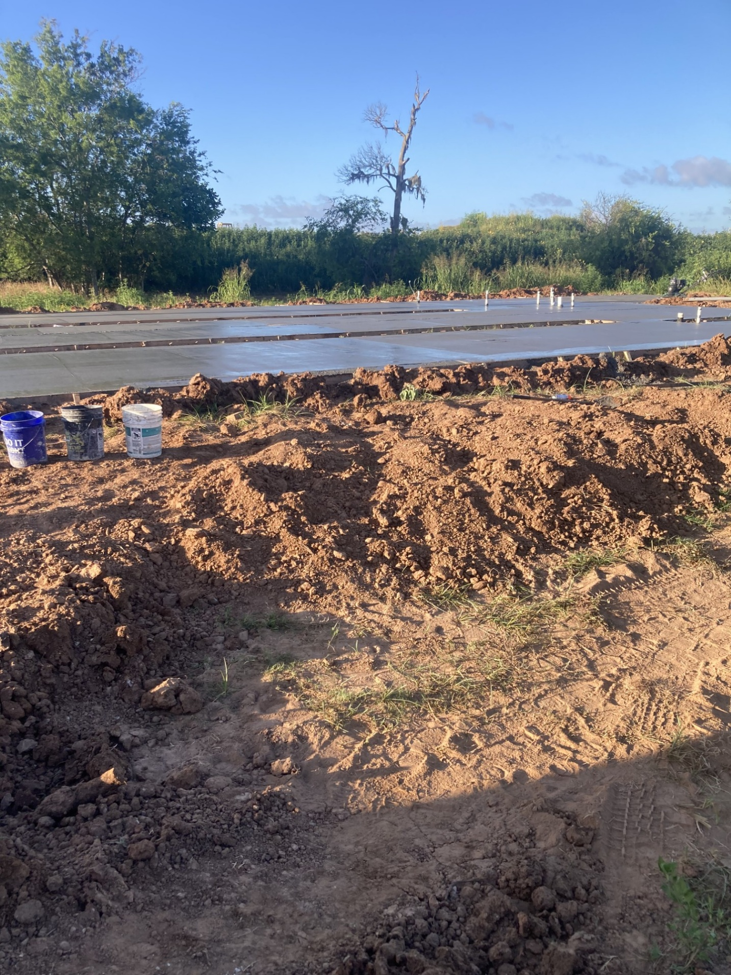
2021 Bond Program – 7,600,000 of $26.5 Million (Phase 1)
Project Name | Pin Oak, North Shady Oaks, Forest Oaks Ln Rehabilitation  Budget: $2,600,000
Project Status | July 2025 Construction: 97%
Project Update | July 2025 - The contractor has moved to the final section of street pavement. The recent high temperatures are making it difficult to get concrete finishers to pour the concrete during daylight hours. Due to the residential nature of the neighborhood, midnight pours are a big ask. They plan to pay more for additional finishers to bring this project to a close. After this area is completed, final yard work and asphalt paving are all that is left.

Any Additional Information for Public

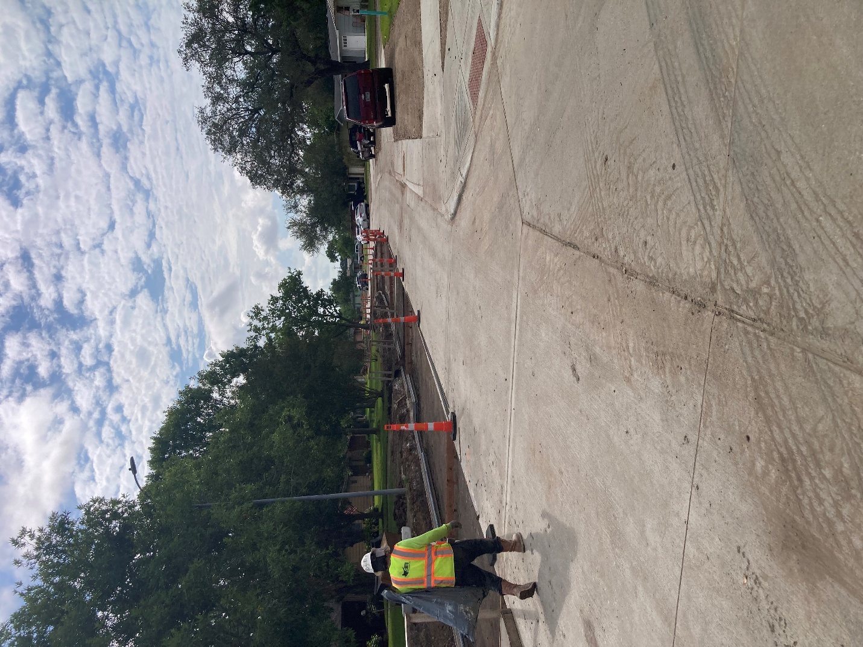
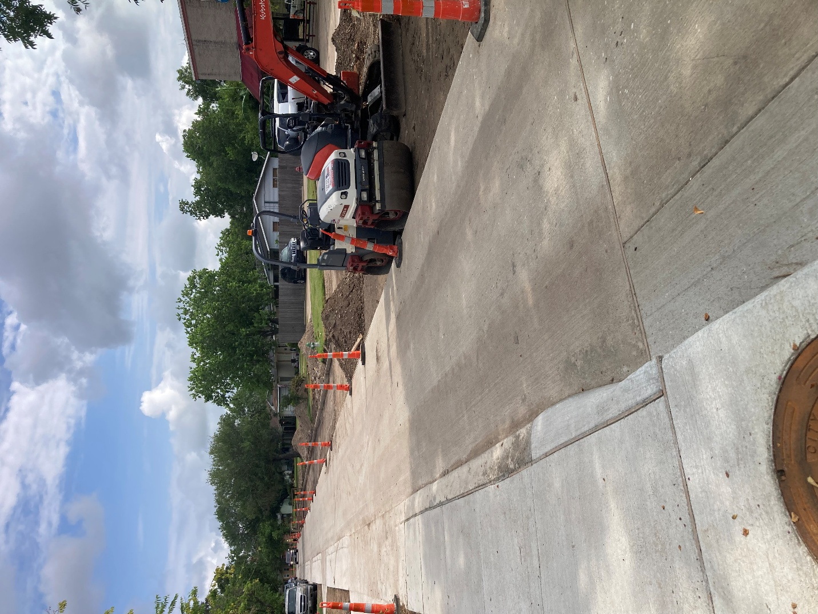

2021 Bond Program – 7,600,000 of $26.5 Million (Phase 1)
Project Name | Street Panel Replacement Phase 1  Budget: $1,000,000
Project Status | Complete 100%

Project Update

Any Additional Information for Public

2021 Bond Program – 16,500,000 of $26.5 Million (Phase 2)
Project Name | Moss, Chestnut, Wisteria, Palm Ln Rehabilitation  Budget: $12,100,000
Project Status | July 2025 Construction: 0%
Project Update | July 2025 - Project was put out for bid. Staff is very familiar with the low bidder and will be recommending that Council authorize the City Manager to sign a contract.
Any Additional Information for Public | Date to be announced for a town hall meeting for residents in the area.

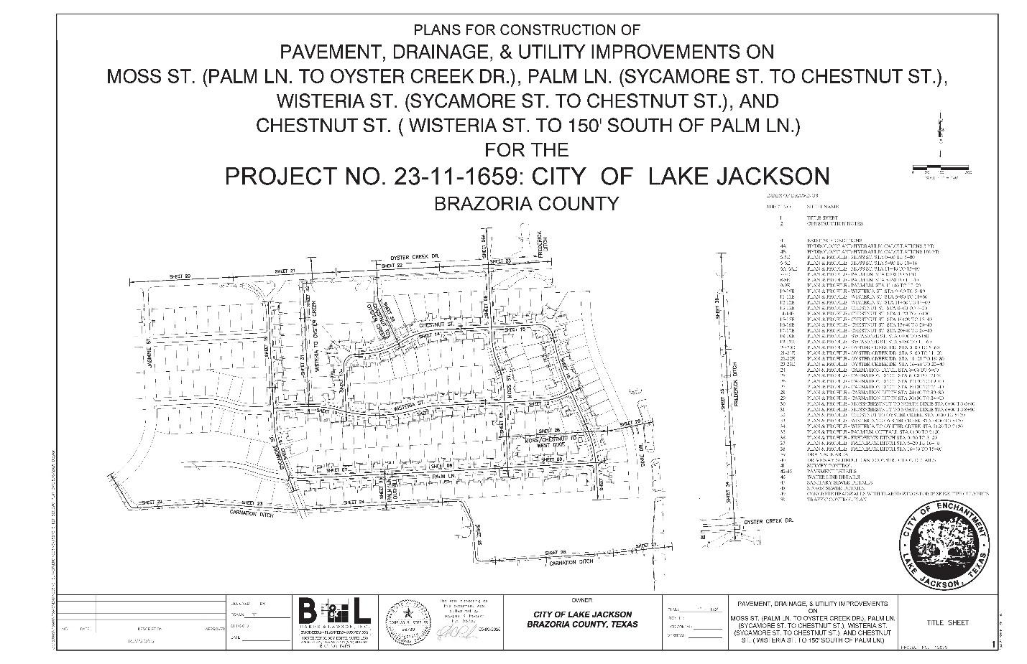

2021 Bond Program – 16,500,000 of $26.5 Million (Phase 2)
Project Name | Willenberg St., Balsam St., Sleepy Hollow Subdivision Street Rehabilitation  Budget: $2,900,000
Project Status | July 2025 Design: 99%
Project Update | July 2025 -The final revisions to the plans are currently underway. The project is expected to be released for sealed bids in August.

Any Additional information for Public

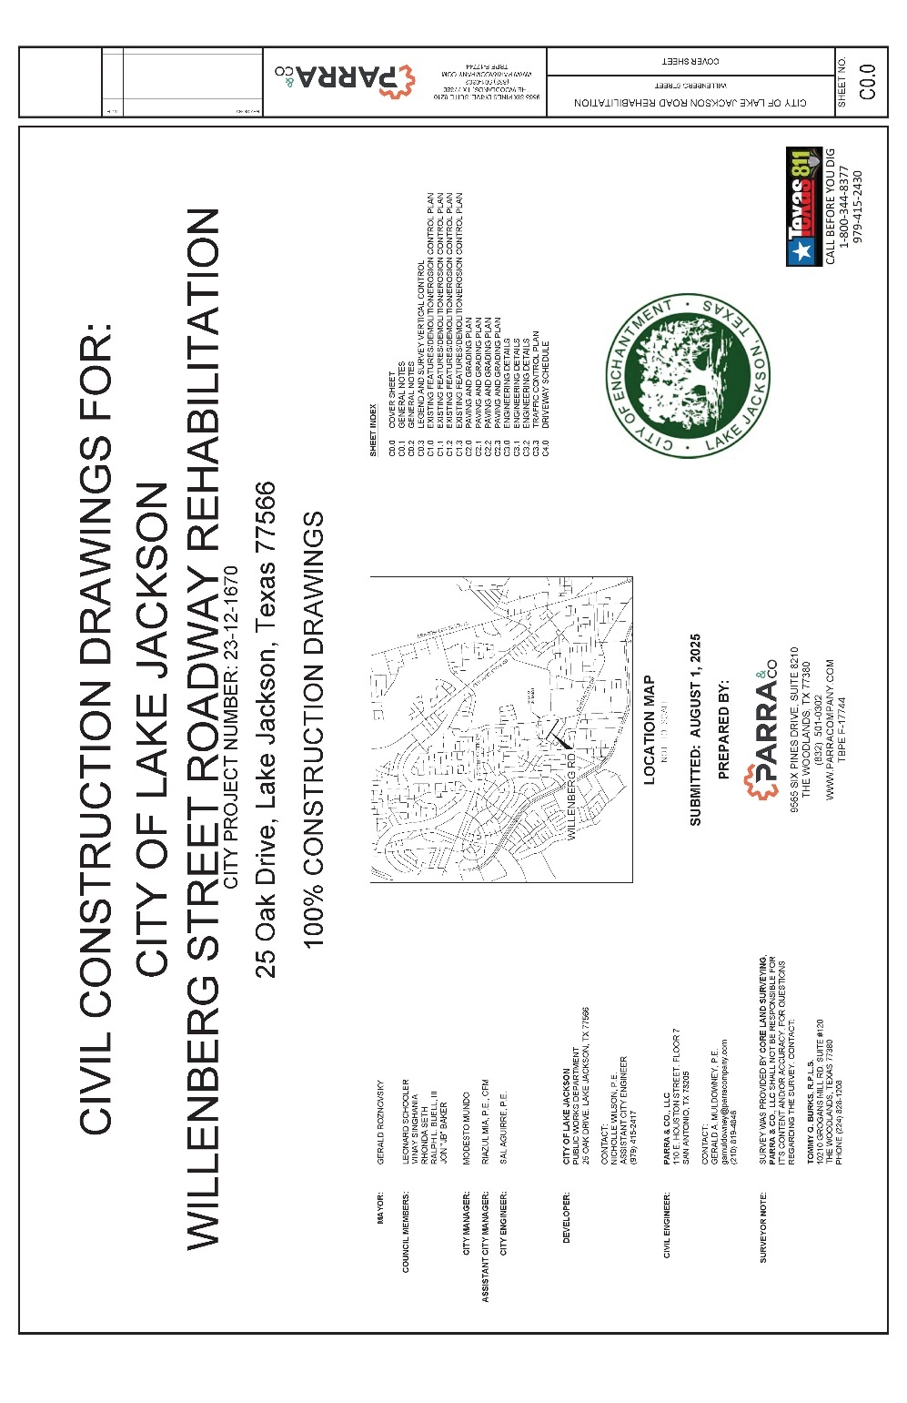

2021 Bond Program – 16,500,000 of $26.5 Million (Phase 2)
Project Name | Street Panel Replacement Phase 2  Budget: $1,500,000
Project Status | July Construction: 10%
Project Update | July 2025 - The contractor has completed work on Sycamore Street and mobilized to North Yaupon. The contractor will be working their way from South to North along Yaupon Street.
Any Additional Information for Public | Raintree Street will be temporarily closed while some additional failing panels near the worksite at the South intersection with Yaupon are replaced.

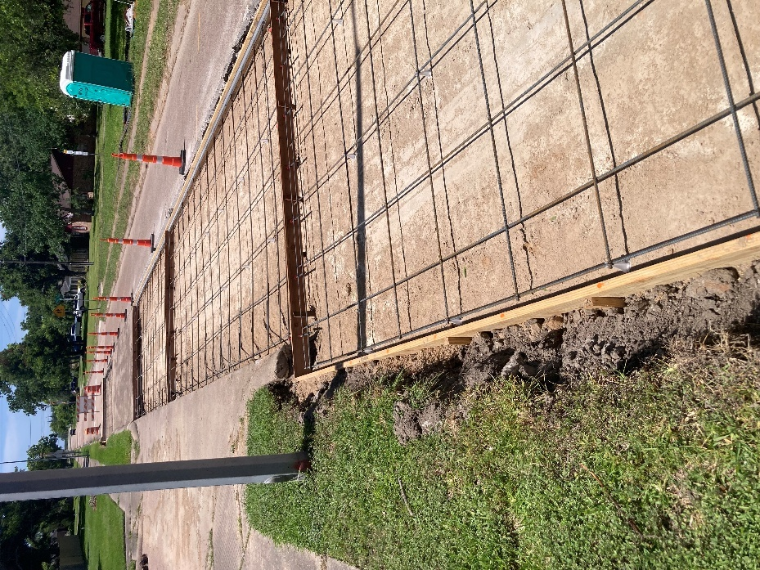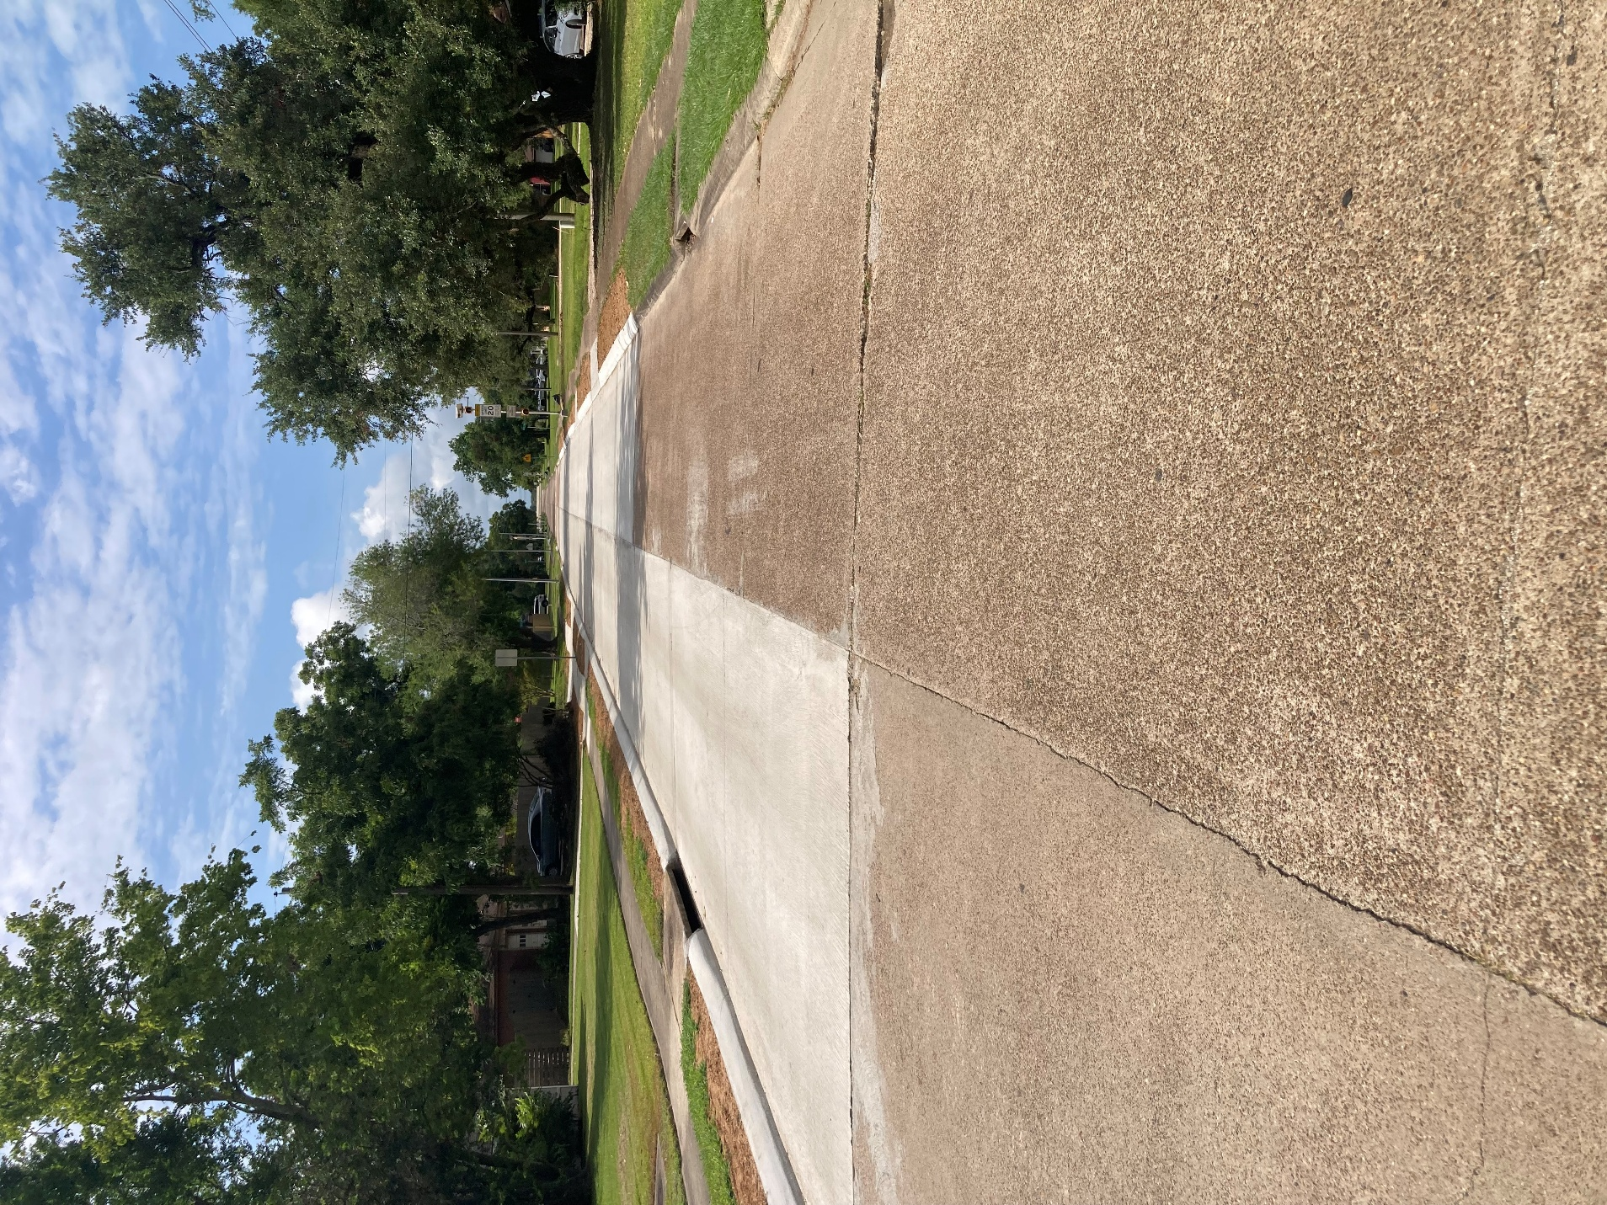
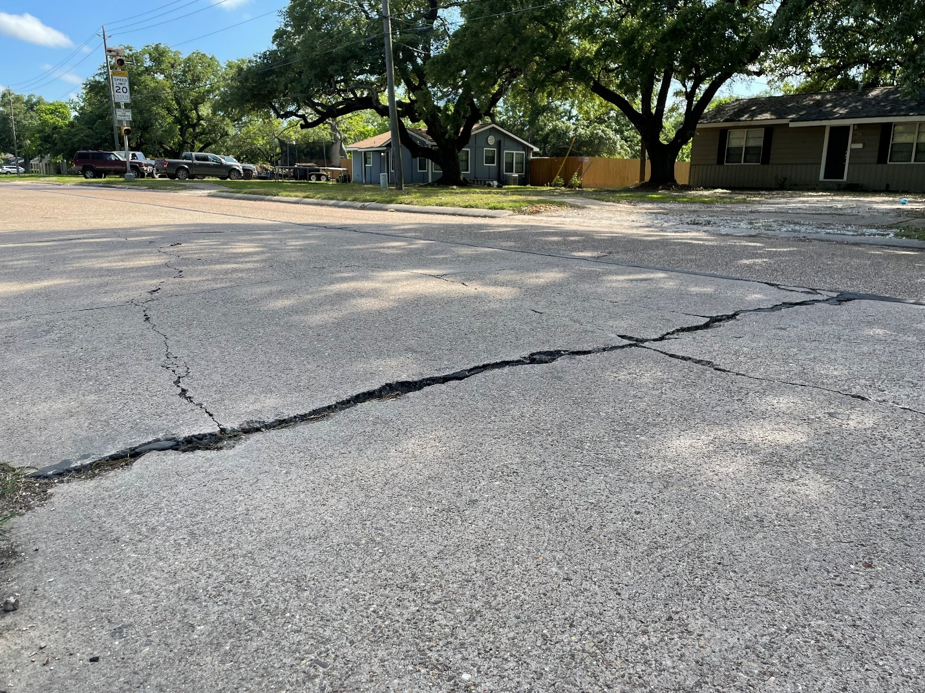
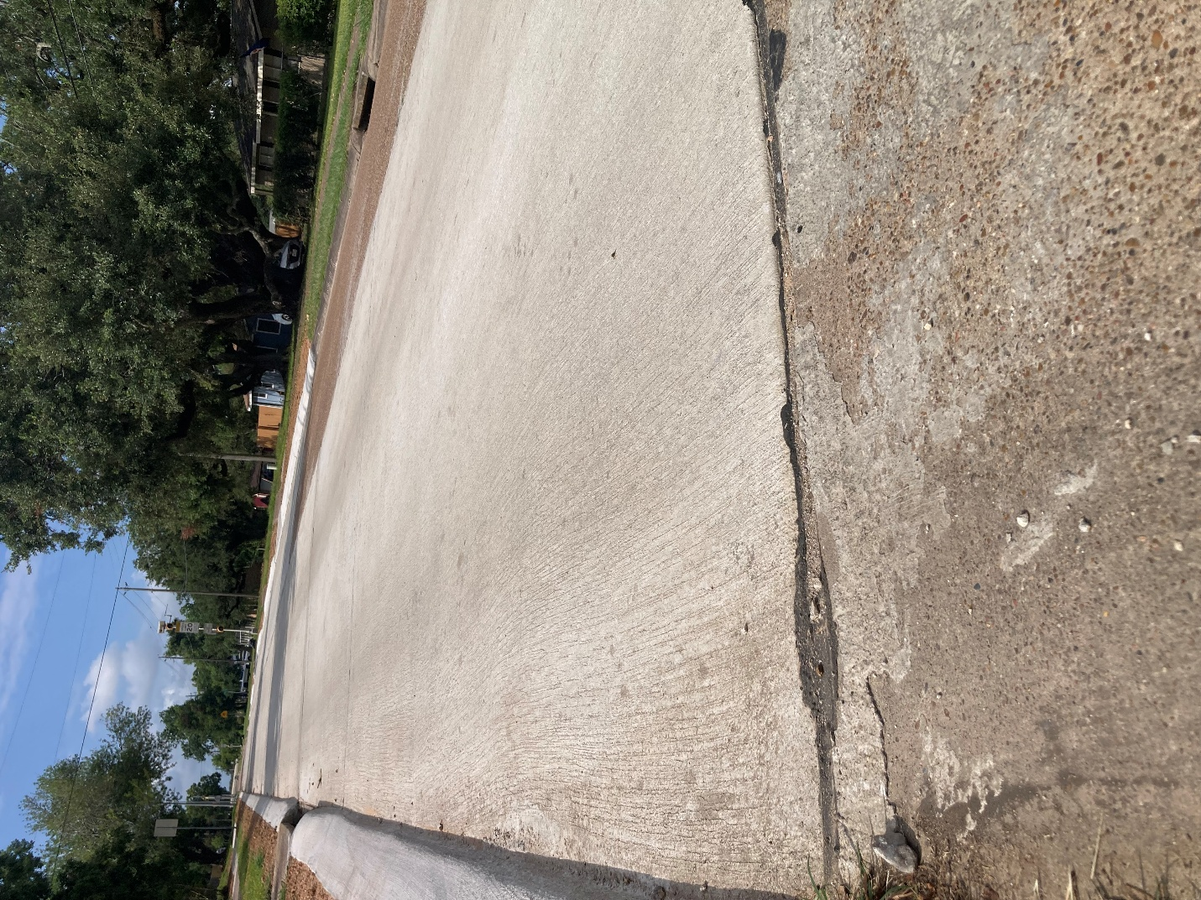

2025 Bond Program – $20,400,000 Million
Project Name | Police Department Expansion  Estimated Budget: $5,400,000 – ($3 Million was approved by voters in 2025 and $2.4 Million was approved by voters in 2021)
Project Status | July 2025 Design: 0%
Project Update | July 2025 - Requests for qualifications were advertised, and statements of qualifications were received. Staff is now working to select one to three architects to interview for Police and Fire building repairs and renovations.

Any Additional Information for Public

2025 Bond Program – $20,400,000 Million
Project Name | Fire Department – Station 1  Estimated Budget: $3,000,000
Project Status | July 2025 Design: 0%
Project Update | July 2025 - Requests for qualifications were advertised, and statements of qualifications were received. Staff is now working to select one to three architects to interview for Police and Fire building repairs and renovations.

Any Additional Information for Public

2025 Bond Program – $20,400,000 Million
Project Name | Street Panel Replacements  Estimated Budget: $8,100,000
Project Status | July 2025 Design: 0%
Project Update | July 2025 - Three statements of qualifications were received and staff recommended Council authorize the City Manager to negotiate contracts with all three engineering firms to get the plans completed and start construction as soon as possible.

Any Additional Information for Public

2025 Bond Program – $20,400,000 Million
Project Name | Drainage  Budget: $4,000,000
Project Status | July 2025 Design: 0%

Project Update

Any Additional Information for Public

