2021 Bond Program – 7,600,000 of $26.5 Million (Phase 1)
Project Name | Animal Services Facility  Budget: $3,700,000
Project Status  (Please indicate percentage completed) | August 2025 Construction: 15%
Project Update  (Please include any information related to, RFQs, bids,  pre-development meetings, etc. that is applicable at the time) | August 2025 - Despite the scattered downpours, the contractor is finding ways to keep moving with the wall framing. The site has been regraded to help the area dry, but each rain brings a new mud problem.

Any Additional information for Public

Photos
August 2025: Animal Services Facility
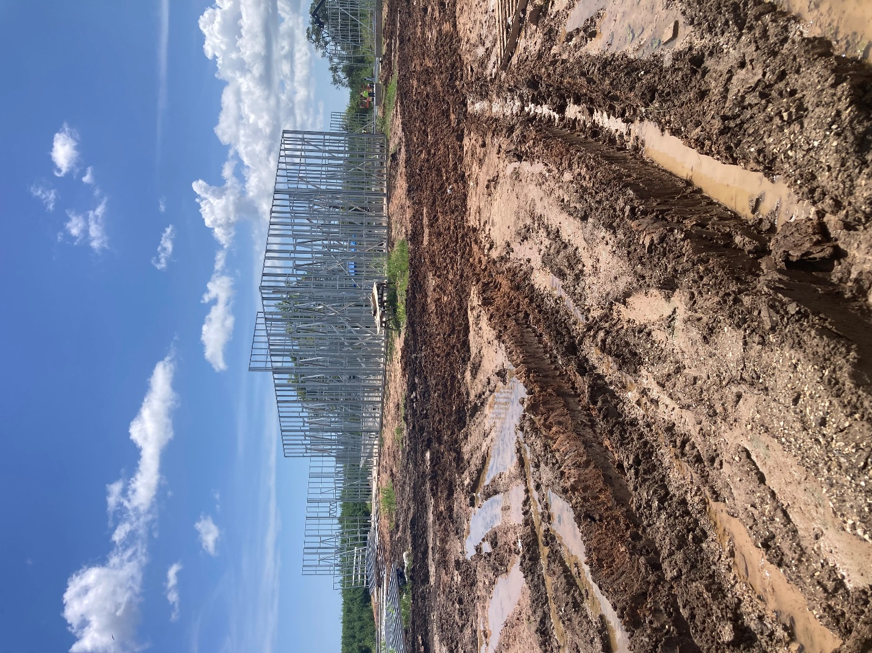

2021 Bond Program – 7,600,000 of $26.5 Million (Phase 1)
Project Name | Pin Oak, North Shady Oaks, Forest Oaks Ln Rehabilitation  Budget: $2,600,000
Project Status  (Please indicate percentage completed) | August Construction: 99%
Project Update  (Please include any information related to, RFQs, bids,  pre-development meetings, etc. that is applicable at the time) | August 2025 - The contractor has poured the last concrete behind the curbs. They lack joint sealing, asphalt patching, final grading, miscellaneous repairs and a final walkthrough inspection. They are demobilizing and cleaning up in September.

Any Additional information for Public

Photos
August 2025: Pin Oak, North Shady Oaks, Forest Oaks Ln Rehabilitation
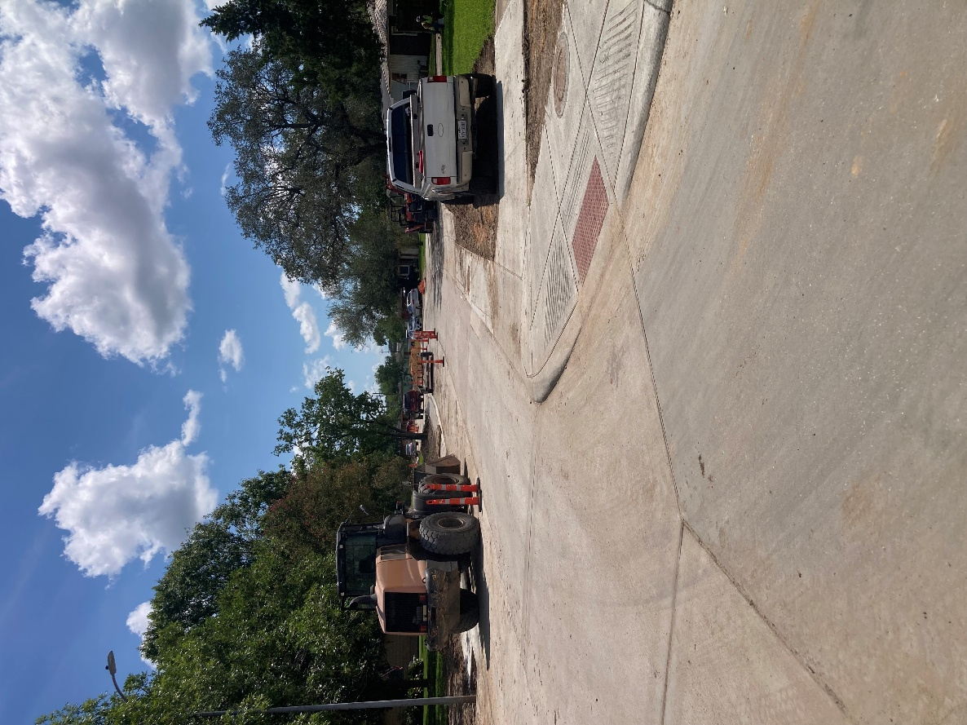

August 2025: Pin Oak, North Shady Oaks, Forest Oaks Ln Rehabilitation_2
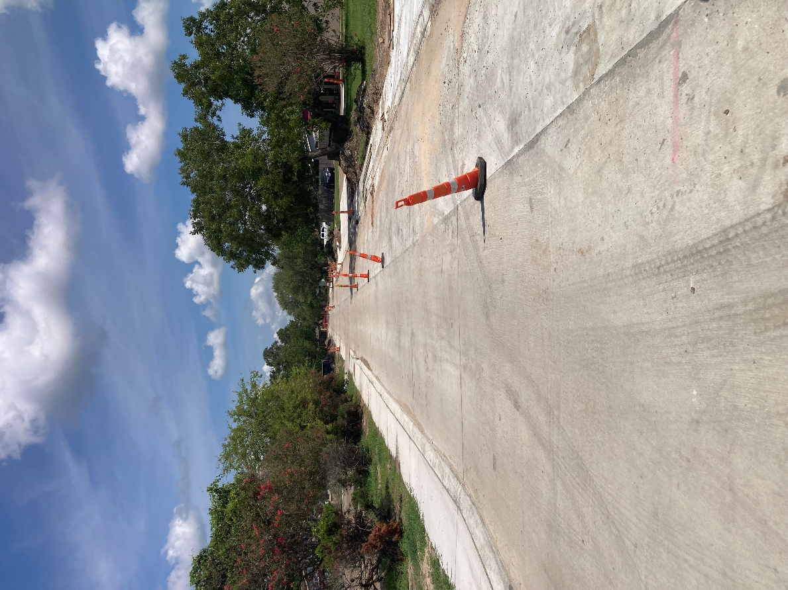

2021 Bond Program – 16,500,000 of $26.5 Million (Phase 2)
Project Name | Moss, Chestnut, Wisteria, Palm Ln Rehabilitation  Budget: $12,100,000
Project Status  (Please indicate percentage completed) | August 2025 Construction: 0%
Project Update  (Please include any information related to, RFQs, bids,  pre-development meetings, etc. that is applicable at the time) | August 2025 - August 18, 2025 - City Council approved awarding the bid for the reconstruction of pavement, utilities, and drainage systems along Moss, Chestnut, Wisteria, and Palm Lane to HTI Construction as the responsive low bidder in the amount of $9,875,449 for contract and a not to exceed amount of $10,862,994, which includes $987,545.00 for a 10% contingency.

Any Additional information for Public

2021 Bond Program – 16,500,000 of $26.5 Million (Phase 2)
Project Name | Willenberg St., Balsam St., Sleepy Hollow Subdivision Street Rehabilitation  Budget: $2,900,000
Project Status  (Please indicate percentage completed) | August 2025 Design: 99%
Project Update  (Please include any information related to, RFQs, bids,  pre-development meetings, etc. that is applicable at the time) | August 2025 - No further project update at this time.

Any Additional information for Public

2021 Bond Program – 16,500,000 of $26.5 Million (Phase 2)
Project Name | Street Panel Replacement Phase 2  Budget: $1,500,000
Project Status  (Please indicate percentage completed) | August 2025 Construction: 15%
Project Update  (Please include any information related to, RFQs, bids,  pre-development meetings, etc. that is applicable at the time) | August 2025 - The contractor has completed work on the outside lane of Yaupon between Fir Street and Banyan Street intersections. They have moved to the inner lane of this area.

Any Additional information for Public

Photos:
August 2025: Street Panel Replacement Phase 2
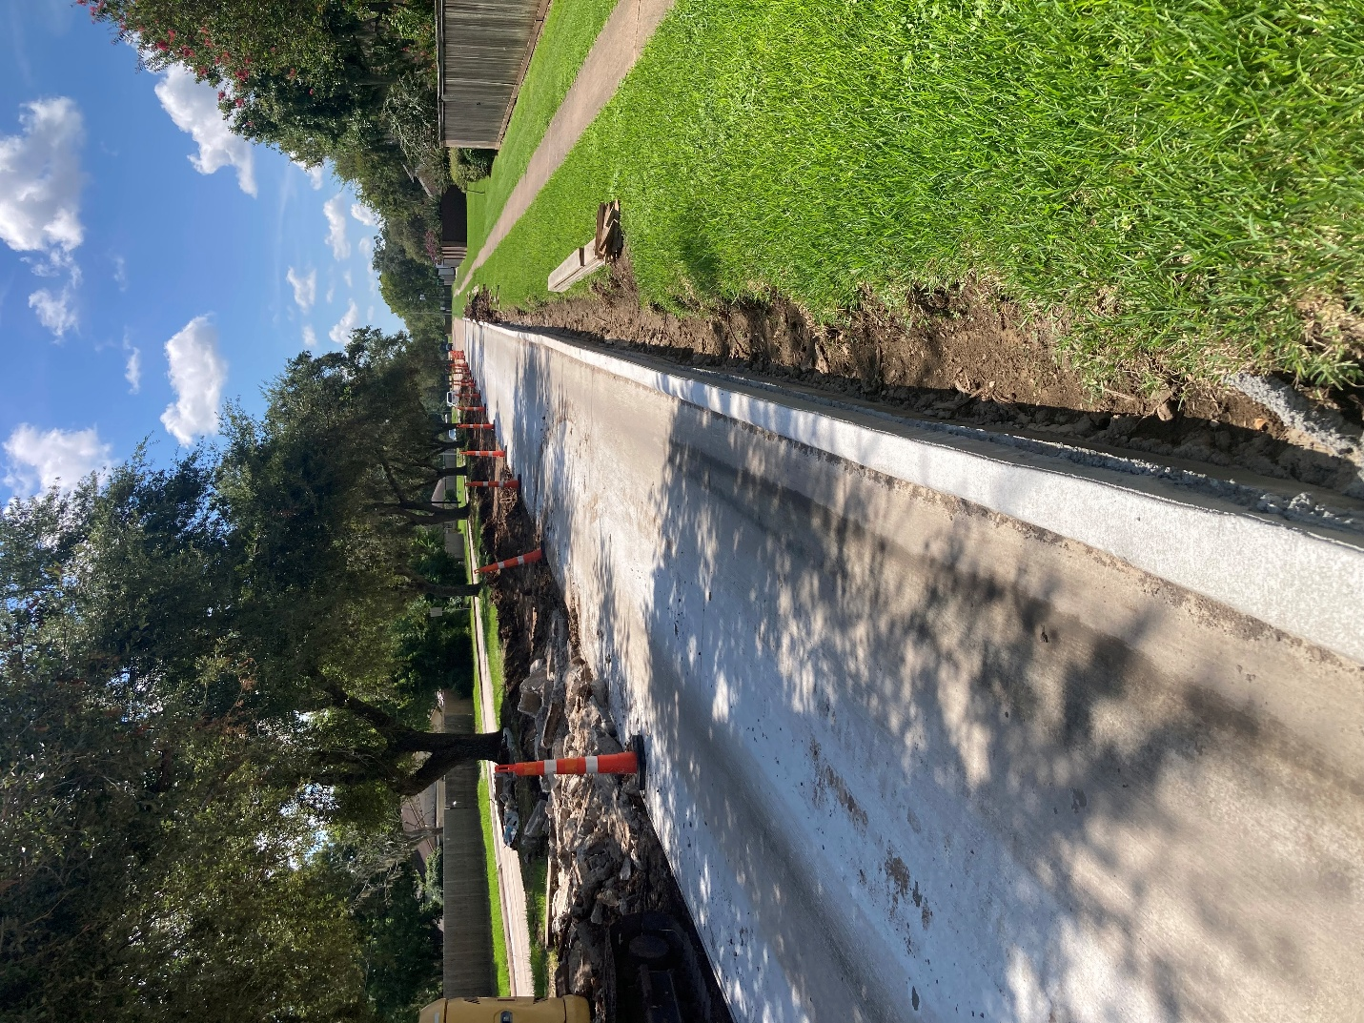

August 2025: Street Panel Replacement Phase 2_2
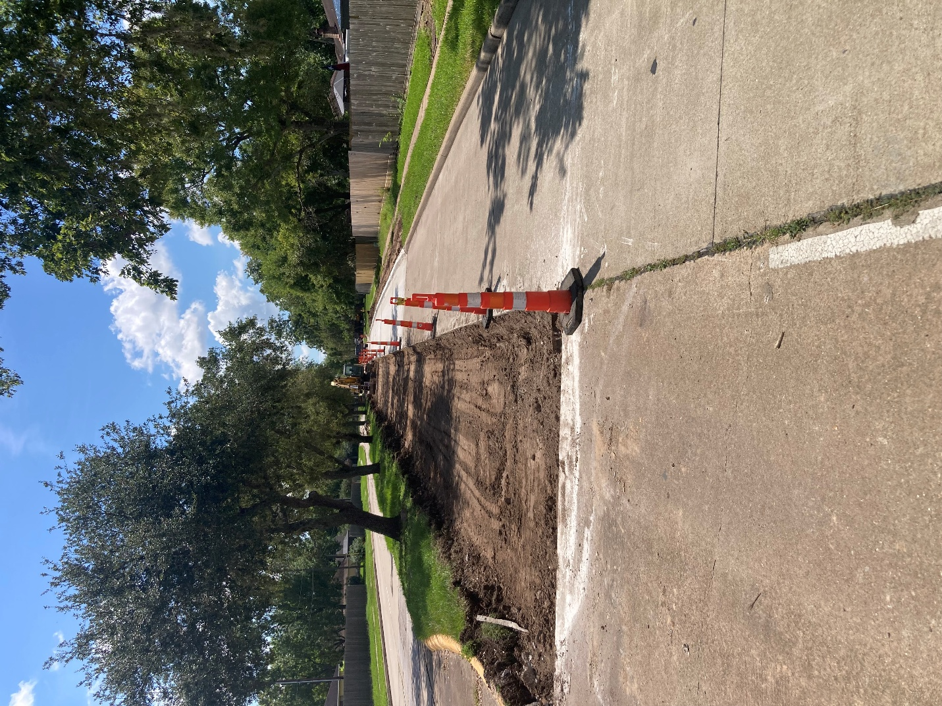

2025 Bond Program – $20,400,000 Million
Project Name | Police Department Expansion  Estimated Budget: $5,400,000 – ($3 Million was approved by voters in 2025 and $2.4 Million was approved by voters in 2021)
Project Status  (Please indicate percentage completed) | August 2025 Design: 0%
Project Update  (Please include any information related to, RFQs, bids,  pre-development meetings, etc. that is applicable at the time) | August/September 2025 - On September 2, 2025 – City Council approved the selection of two firms, iAD and PGAL, for the design of the 2025 Bond for Public Safety Facilities and authorized the City Manager to negotiate two contracts for professional architectural and engineering services.

Any Additional information for Public

2025 Bond Program – $20,400,000 Million
Project Name | Fire Department – Station 1  Estimated Budget: $3,000,000
Project Status  (Please indicate percentage completed) | August 2025 Design: 0%
Project Update  (Please include any information related to, RFQs, bids,  pre-development meetings, etc. that is applicable at the time) | August/September 2025 - On September 2, 2025 – City Council approved the selection of two firms, iAD and PGAL, for the design of the 2025 Bond for Public Safety Facilities and authorized the City Manager to negotiate two contracts for professional architectural and engineering services.

Any Additional information for Public

2025 Bond Program – $20,400,000 Million
Project Name | Street Panel Replacements  Estimated Budget: $8,100,000
Project Status  (Please indicate percentage completed) | August 2025 Design: 0%
Project Update  (Please include any information related to, RFQs, bids,  pre-development meetings, etc. that is applicable at the time) | August 2025 - On August 4, 2025 – City Council approved the selection of three separate engineering firms—Baker & Lawson, Dunaway, and Parra & Co.—for the 2025 Bond Spot Repairs of concrete pavement panels and authorized the City Manager to negotiate three separate contracts for design engineering professional services.  Meetings with the selected engineers are being scheduled to review the portions of the project that each will be designing and get estimates for review.

Any Additional information for Public

Photos:
August 2025 – 2025 Street Assessment
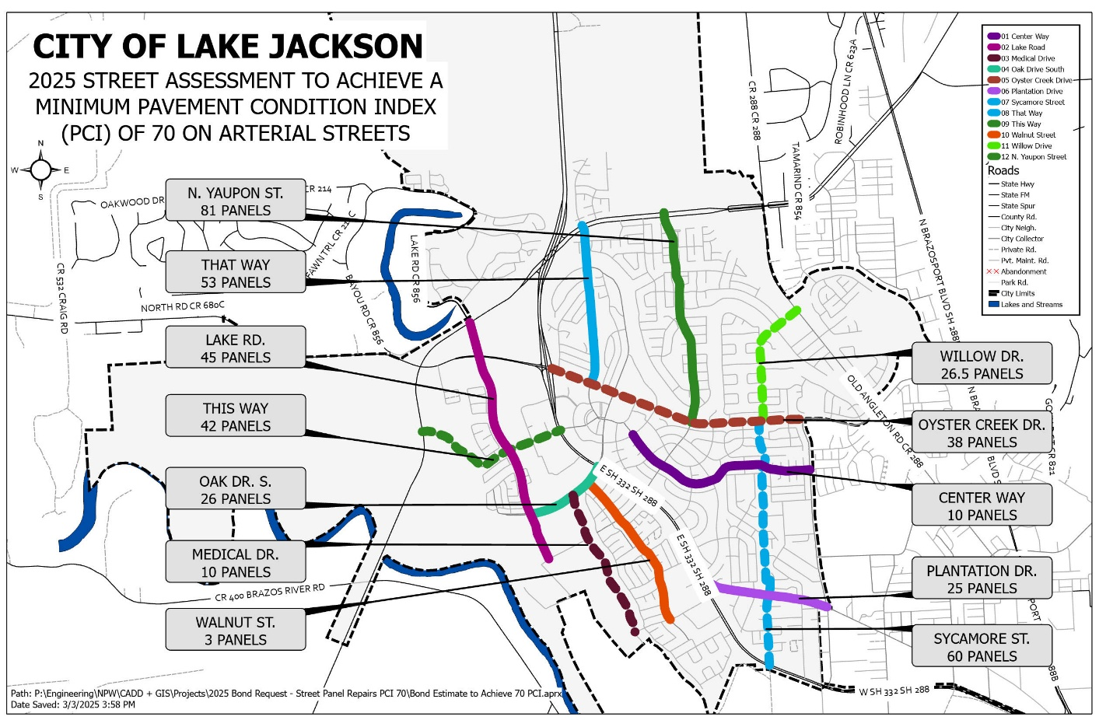

2025 Bond Program – $20,400,000 Million
Project Name | Drainage  Budget: $4,000,000
Project Status  (Please indicate percentage completed) | August 2025 Design: 0%
Project Update  (Please include any information related to, RFQs, bids,  pre-development meetings, etc. that is applicable at the time) | August 2025 - No current projects at this time.

Any Additional information for Public

